*Instructions to run the Application*

1. Make sure you have eclipse IDE installed in your system.
2. Make sure that you have the latest Java JDK version installed in your system
3. Install “e(fx)clipse” from Eclipse Marketplace
4. Download JavaFX SDK
5. Create a User Library for JavaFX
   1. Eclipse -> Preferences -> Java -> Build Path -> User Libraries
   2. New a “User Library” -> Name is “JavaFX”
   3. Press “Add External JARs” and select all .jar from “lib” directory of downloaded JavaFX SDK.
6. Unzip the submitted project zip file and open the OOD_FinalProject_highFive JavaFX project in your eclipse IDE.
   1. Right click project -> Properties -> Java Build Path
   2. In Libraries tab:
      1. click “Modulepath”
      2. select “Add Library ...” button
      3. choose “User Library”
      4. choose “JavaFX” -> “Finish” -> “Apply” -> “Apply and
      5. Close”
7. Set arguments for running the project
   1. Right click on “Main.java” -> “Run As” -> “Run Configurations”
   2. In “(x) = Arguments” tab -> VM arguments, type in
   3. following arguments:
   4. 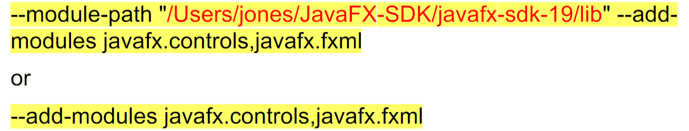
8. Click on run
9. Note: You have to run the app again to see the Player’s score because, the scores are stored in a file and it’ll take time to reflect the changes made to the file